- Date of submission
- Member State: | Finland
- Name of the disease: | IHN
- Contact details: | The government of Åland  PB 1060  AX-22111 MARIEHAMN  ÅLAND, Finland
- E-mail: | registrator@regeringen.ax  CVO-Finland.mmm@gov.fi
- Responsibility within the competent authority: | The Ministry of Agriculture and Forestry is responsible for declaring compartments free of aquatic animal diseases in accordance with Article 83 of Commission Delegated Regulation 2020/689. The Finnish Food Authority is responsible for publishing provisional declarations of compartments free from disease on its website. The Government of Åland is responsible for implementing the rules on eradication and control of animal diseases in Regulation (EU) 2016/429 and the Finnish Act on Animal Diseases (76/2021). The Åland Environmental and Health Authority (ÅMHM) is the competent authority for carrying out inspections and controls on the holdings.
- Name: | Government of Åland, Department of Social Affairs, Health and Environment.
- Identification of the grounds for recognition of disease-free status:
  - absence of listed species:
  - disease agent’s incapacity to survive
  - historical and surveillance data

- completion of an eradication programme | x
- Territorial scope of the eradication programme:

  - zone
- compartment | x
- In the case of dependent compartments as referred to in point (b) of Article 73(2) of Regulation (EU) 2020/689:

- the assessment referred to in point (a) of Article 73(3) of the same Regulation; and | (i) Geographical location of each establishment in the compartment and the nature of water supply  Coastal dependent compartment comprised by the parts of Eckerö and Hammarland municipalities in Åland Islands, Finland that is contained within a circle of radius 10 km, centred on WGS84 coordinates 10 km, centred on WGS84 coordinates Lat 60,207175390°, Lon 19,507907780. There are no physical barriers between this compartment and other sea areas. All the surrounding sea areas are officially IHN free (Finland and Sweden).  There are 5 (n 5) fish farming establishments in the compartment and two slaughterhouses. All five establishments had IHN susceptible species (rainbow trout) in 2022 and one of them was infected in 2022. The other four establishments, all owned by the same company, remained non-infected. Two of the establishments are in use only during spring-autumn and two only during autumn-spring.  1. 023 126 N: 60,217367°E: 19,426233°  2. 024 128 N: 60,252533° E: 19,471583°  3. 025 127 N: 60,248145 ° E: 19,514248°  4. 026 113 N: 60,208897°E: 19,549956°  5. 027 125 N: 60,252394°E: 19,494556°  ii) health status of the other aquaculture establishments in the water system  The surrounding sea-areas are officially free of IHN (Finland and Sweden.  (iii) the location of the establishments referred to in point (ii) and their distance from the dependent compartment;  The closest active aquaculture establishment is located about 23 km from the border of the compartment. This establishment has been tested negative once a year.  (iv) production volume of the establishments referred to in point (ii) as well as their method of production and the source of their animals;  In 2024, 4 916 000 kg of fish were produced in Åland (4 561 469 kg rainbow trout and 354 292 kg whitefish). Most of the fish are farmed in open net pens but there are also two land-based recirculating aquaculture system facilities in Åland. All fish farmed for human consumption are moved or imported from outside the area from areas or establishments certified as free of IHN (mainland Finland, USA and Estonia) as juveniles or roe. Fish grown for restocking purposes in Åland are produced from brood fish within the area.  (v) presence and abundance of wild aquatic animals from relevant listed species in the water system and their health status  (vi) details of whether the species referred- to in point (v) are sedentary or migratory;  (vii) possibility of the wild aquatic animals referred to in point (v) entering the compartment;  Wild fish move freely in the compartment. Anadromous Atlantic salmon cross the area during their migration. Some rainbow trout escapees may be found but wild rainbow trout do not exist in Åland. Wild fish (northern pike and sea trout) have been tested for IHN in the compartment during the surveillance program with negative test results.  (viii) general biosecurity measures in the compartment;  Approved establishments are required to meet the biosecurity standards in the EU legislation. This is controlled on a regular basis (see point 12.b). The application for approval must include a description of the health control system and biosecurity measurements of the company and each of its farms. All establishments in the compartment and elsewhere in Finland purchase fish from IHN free establishments.  (ix) general hydrological conditions on the water system;  The surrounding water system comprises the sea area with hundreds of small islands in the province of Åland that lies between the Gulf of Bothnia and The Gulf of Finland in the South-Western Finland. Water is brackish water with a salt content of circa 0.30-0.35 %. There are no physical barriers between this compartment and the sea, however all the surrounding areas are declared free of IHN.
- details of any measures which were imposed by the competent authority to prevent the introduction of the relevant disease to the compartment.

- the assessment referred to in point (b) of Article 177 of Regulation (EU) 429/2016:
- Statement confirming that the relevant general criteria in accordance with point (a) of Article 66 of Regulation (EU) 2020/689 for zones, or with point (a) of Article 73(1) of that Regulation for aquatic compartments, are complied with. | It is confirmed that the relevant general criteria in accordance with point (a) of Article 73(1) of Regulation (EU) 2020/689 are complied with.  IHN was detected in a land-based RAS establishment in Eckerö, Åland in June of 2022 and an IHN eradication programme was launched. The establishment with outbreak was emptied, cleaned and disinfected and fallowed for a period of >6 weeks under the control of the authority. Despite a thorough epidemiological investigation, the origin of the infection could not be established. All fish in the establishment originated from IHN free establishments outside Finland and the nearest establishments in the area remained IHN free.  In 2023, a surveillance programme started with a plan of declaring the whole compartment free of IHN in two years. According to the programme, each establishment keeping susceptible species >4 months per year was inspected and sampled twice a year with a sample size of 75 fish and each establishment keeping susceptible species <4 months per year was inspected and sampled once per year with a sample size of 75 fish. However, in 2024 one of the establishments keeping susceptible species >4 months were sampled only once due to the late moving of fish to the site and therefore water temperature rising much over 14 degrees. That establishment has been sampled in July 2025 with negative test results.
- When the grounds for recognition of disease-free status is based on the completion of an eradication programme, for each year of the programme, information must be supplied concerning:

  - the aquaculture establishments and where relevant, the sampling points in the wild in the zone/compartment:

- Number of approved aquaculture establishments in the programme; | Two companies with a total of 5 approved establishments with rainbow trout.
- Number of registered aquaculture establishments in the programme (where relevant);
- Number of sampling points in wild populations (where relevant); | During the surveillance programme a total of 7 samples from wild fish (2 northern pike and 5 sea trout), were caught in the compartment. All samples tested negative by virus isolation.
- Maps showing approved and registered aquaculture establishments, and where relevant, sampling points in the wild; | 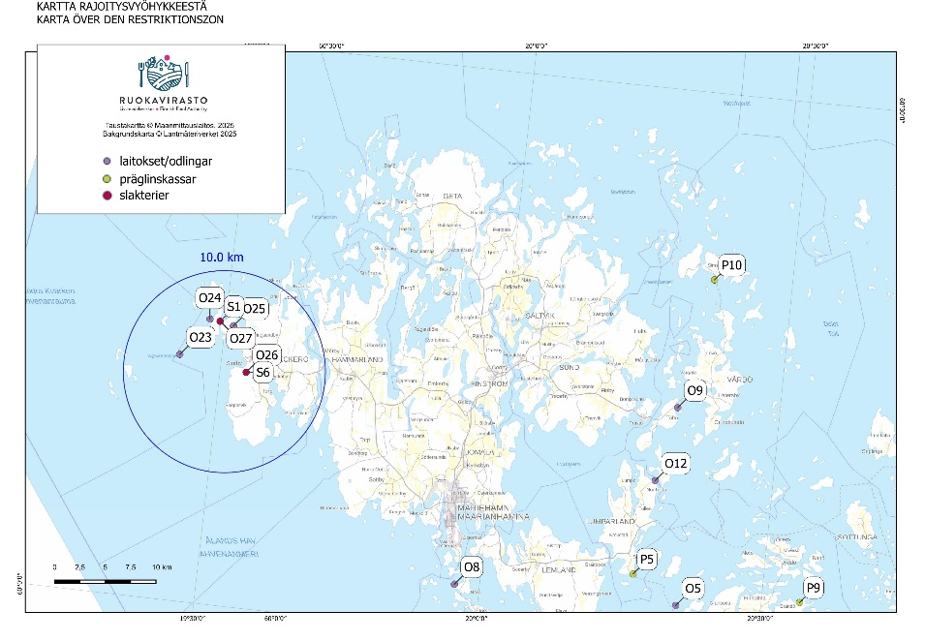
- Number of aquaculture establishments, and where relevant, sampling points in the wild, out of the total number of aquaculture establishments and sampling points in the wild, which are not infected; | year 2023: 5/5 establishments tested were free of IHN  years 2024 and 2025: 5/5 establishments tested were free of IHN (one of the establishments has been tested the second time in July 2025)
- Number of aquaculture establishments, and where relevant, sampling points in the wild, out of the total number of aquaculture establishments and sampling points in the wild, with confirmed cases; | 0
- Number of new aquaculture establishments, and where relevant, sampling points in the wild, out of the total number of aquaculture establishments and sampling points in the wild, with confirmed cases. | 0
  - animal health visits and sampling which have been completed:

- Number of health visits per approved and where relevant, per registered aquaculture establishment; | two health visits per year in approved establishments keeping fish >4 months per year, one health visit per year in approved establishments keeping fish <4 months per year.
- Number of samplings per approved, and where relevant, per registered aquaculture establishment, or samplings in wild populations; | establishments with fish of susceptible species for >4 months per year have been sampled two (2) times yearly. Establishments with fish of susceptible species <4 months have been sampled one (1) time yearly.
- Number of animals sampled at each sampling event; | 75
- Species sampled; | rainbow trout
- Results from each laboratory examination (positive/ negative for the pathogen in question); | all negative
- Results from each clinical inspection; | no clinical signs
- Water temperature at the time of sampling. | below 14°C.

